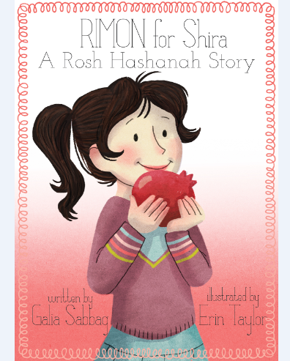Class: _____________ Date: _____________ Teacher: _______________

**Subject:** Rosh Hashanah- using the book: “RIMON for Shira”

|  |  |  |  |  |  |
| --- | --- | --- | --- | --- | --- |
| יום שני  Monday | יום שלישי  Tuesday | יום רביעי  Wednesday | יום חמישי  Thursday | יום שישי  Friday |  |
| Organization: class decorations, song on smart board or computer, shofar, blindfolds, supplies for ROSH HASHANAH cards, homework assignment. | Organization: Shofar, song, greeting cards, Holiday foods or pictures, blessings, CHALLAH ingredients, oven for baking, homework page. | Organization: song, shofar, cards, foods, blessings, pomegranates for tasting and display, blessings, supplies for a RIMMON bowl, homework requests. | Organization: song, shofar, greetings, foods, blessings, RIMMON display and exploration corner, cookbook supplies, homework requests. | Organization: smart board or computer to watch IPhone videos, song, shofar, greetings, foods +blessings, book: “RIMON for Shira” or e-Reader, smart board or a computer for ROSH HASHANAH games. | Time line: |
| Introduce the words: ROSH= head, SHANAH= year.  Ask: what year is coming up in the Jewish calendar? What Jewish month?  Teach a ROSH HASJANAH song using movement.  (suggestion: <http://www.youtube.com/watch?v=FlcxEDy-lr0> )  Introduce the SHOFAR and its sounds using the Shira’s series web page resources: [www.shirasseries.com](http://www.shirasseries.com) Practice sounds.  Activity: On ROSH HASHANAH we say: SHANAH TOVAH= good year as a greeting to each other; cover 2 children’s eyes, twirl them a bit and ask them to find each other by calling loudly: SHANAH TOVA repeatedly. When they find each other, they shake hands and another pair of players gets a turn to speak the Hebrew greeting.  Create: ROSH HASHANAH cards.  Learning check: what the word ROSH means? What is SHANAH?  What do we say to each other on ROSH HASHANAH? | Review ROSH HASHANAH song, SHOFAR sounds and SHANAH TOVAH greeting.  Activity: Teach the traditional foods for ROSH HASHANAH: apples and honey for a sweet year- add the Hebrew:  שתתחדש עלינו שנה טובה ומתוקה.  Round CHALLAH for the circle of life- add HAMOTZY:  ברוך אתה אדוני אלוהינו מלך העולם המוציא לחם מן הארץ.  A whole fish for being a head (ROSH) and not a tail in the coming new year-  שנהיה לראש ולא לזנב.  Create: bake a round CHALLAH, using the Shira’s series web page resources: [www.shirasseries.com](http://www.shirasseries.com)  Learning check: why do we eat apples and honey on ROSH HASHANAH?  Why round CHALLAH?  Why a whole fish? | Review ROSH HASHANAH song, SHOFAR sounds and SHANAH TOVAH greeting, Holiday foods: apple and honey, round CHALLAH, fish with the head and tail.  Activity: add the RIMON fruit, for having as many MITZVOT (commandments in the new year that is arriving, as there are seeds in the RIMON)  שירבו זכויותינו כרימון  Present the fruit to the class, say the blessing:  ברוך אתה אדוני אלוהינו מלך העולם בורא פרי העץ.  Add the SHEHECHEYANU prayer for eating a fruit for the first time:  ברוך אתה אדוני אלוהינו מלך העולם שהחיינו וקיימנו והגיענו לזמן הזה  Cut and taste the fruit.  Create: a RIMON fruit bowl.  Learning check: why do we eat RIMMON on ROSH HASHANNA? | Review ROSH HASHANAH song, SHOFAR sounds and SHANAH TOVAH greeting, Holiday foods: apple and honey, round CHALLAH, fish with the head and tail + RIMMON.  Activity: Explore the RIMMON display. Color? How many seeds? Crown? Is there a RIMMON on the TORAH?  Create: assemble, color and publish a class ROSH HASHANAH cookbook for each child, using the recipes from the student’s homes.  Ask each child to give a cookbook to another with the greeting: SHANAH TOVAH. The recipient can answer: TODA (thank you).  Learning check: who can name 3 facts about the RIMMON? | Watch IPhone videos, review ROSH HASHANAH song, SHOFAR sounds and SHANAH TOVAH greeting, Holiday foods: apple and honey, round CHALLAH, fish with the head and tail + RIMMON.  Read the story: “RIMON for Shira”  Discuss the story with questions like: why did Shira want to buy a RIMMON? Why the supermarket attendants did not know what a RIMMON is? Can you think of more Hebrew words we use almost every day?  Take home “RIMMON for Shira” book, or send a link to the eBook:  **********************  Activity: Play on the smart board or on computers ROSH HASHANAH games:  <http://games.yo-yoo.co.il/game_play.php?id=1218>  Learning check: what is RIMMON in English☺? | *5 min-*  *Welcome.*  *Teach*  *review-*  *10-15 min*  *Activity-*  *10-15 min*  *Cerate- 20-30 min*  *Learning check-*  *5 min* |
| **Homework:** send a favorite ROSH HASHANAH recipe for a class holiday cook book. | **Homework**: work page- coloring or matching food to its blessing. | **Homework**: bring a RIMMON from home for a class Holiday display. | **Homework:**  Read class’ cookbook or take a short IPhone video making a recipe from the cookbook. | **Homework:**  0 MENUCHA!! | H.W. –  5 min |

* This lesson plan is a suggestion…. Each teacher will have to tailor it to her\his class and age group.

* The plan can be spread over 2 or even 3 weeks.

* Extension unit could be: after learning and practicing, students make “their own” TASHLICH in class. Using a small blow-up pool- students will throw bread into the water and say: SLICHA סליחה --- another word in Hebrew that we use on ROSH HASHANAH!

* Suggestions, ideas, improvements, anecdotes and comments are welcomed and greatly appreciated at: [www.Shirasseries.com](http://www.Shirasseries.com)

Thank you!

Blessings,

Galia Sabbag

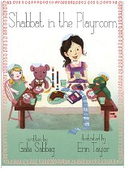If you liked “RIMMON for Shira” you will love:

"Shabbat in the playroom" and the Shira series.

eBook is available on Amazon Kindle and on Barnes and Noble Nook.

Printed copies are available through the website.

[www.shirasseries.com](http://www.shirasseries.com)

[Facebook.com/Shira.series](http://Facebook.com/Shira.series)

@shirasSeries

Shalom,

I am super excited to share with you that my new eBook: "RIMON for Shira- a Rosh Hashanah story" is published and available on Amazon:

<http://www.amazon.com/Rimon-Shira-Shiras-ebook/dp/B00ETHSPY8/ref=sr_1_1?ie=UTF8&qid=1377719910&sr=8-1&keywords=RIMON+for+Shira>

 and on Barnes and Noble:

<http://www.barnesandnoble.com/w/rimon-for-shira-galia-sabbag/1116783053?ean=2940148423263> .

Please check out the website: [www.shirasseries.com](http://www.shirasseries.com/) or follow Shira on twitter: @shirasSeries .

Please share this info with everybody....

Thank you!

With blessings of Shannah Tova,

Galia